|  |  |
| --- | --- |
| **Ex. No. 1** | **Design a Web Page using HTML** |
| **Date of Exercise** | 18/07/2022 |
| **Web Host Link** |  |
| **Youtube Link** | https://youtu.be/JhSuA7sllqQ |

**Aim**

Create a HTML web page for your Personal Profile that conforms to HTML features and has the following elements: doctype, html, meta (in the revised html5 format), title, head, body, div, p, headings, image, anchor, table, list, html comment

**Description**

* **<head>** Defines information about the document
* **<title>** Defines the title of a document
* **<body>** The tag defines the document's body
* **<div>** Thetag defines a division or a section in an HTML document.
* **<p>** The Paragraph element. The <p> HTML element **represents a paragraph.**
* **<h>** HTML defines six levels of headings. A heading element implies all the font changes, paragraph breaks before and after, and any white space necessary to render the heading. The heading elements are H1, H2, H3, H4, H5, and H6 with H1 being the highest (or most important) level and H6 the least.
* **<img>** The tag is used to embed an image in a web page
* **<a href>** An anchor is a piece of text which marks the beginning and/or the end of a hypertext link
* **<table>** An HTML table consists of one <table> element and one or more <tr>, <th>, and <td> elements
* **<li>**

**Description List** or Definition List displays elements in definition form like in dictionary. The <dl>, <dt> and <dd> tags are used to define description list.

The 3 HTML description list tags are given below:

1. **<dl> tag** defines the description list.
2. **<dt> tag** defines data term.
3. **<dd> tag** defines data definition (description).

**Program**

<!DOCTYPE html>

<HTML>

<head>

    <style>

        p.text {

            font-weight: bold;

            font-size: 20px;

        }

        h1 {

            text-align: center;

        }

        #right {

            float: right;

        }

        table {

            font-family: arial, sans-serif;

            border-collapse: collapse;

            width: 50%;

        }

        td,

        th {

            border: 1px solid #dddddd;

            text-align: left;

            padding: 8px;

        }

    </style>

    <title>Resume</title>

</head>

<body>

    <h1>My Resume Page</h1>

    <div id="right">

        <img src="C:\Users\MANIKANTAN\Desktop\my photos\sandhia photo.jpg" width='200' height='200'>

    </div>

    <p class="text">M.Sandhia

        <br>16 A

        <br>thiagarajar colony

        <br>pasumalai madurai 4

        <br>Ph: 98272452390

        <br>Email: sandhiam2003@gmail.com

    </p>

    <a href="https://www.linkedin.com/in/m-sandhia-a02636209/">Visit My Website</a>

    <a href="https://online.karunya.edu/oauth/login">My College</a>

    <a href="https://mail.google.com/mail/u/0/#inbox">Email Me</a>

    <a href="https://www.linkedin.com/in/m-sandhia-a02636209/">Call Me</a>

    <img src="C:\Users\MANIKANTAN\Downloads\mail photo.png" width='100' height='50'>

    <img src="C:\Users\MANIKANTAN\Downloads\linkedin.png" width='100' height='50'>

    <img src="C:\Users\MANIKANTAN\Downloads\facebook.jpg" width='100' height='50'>

    <h3>Career Objective</h3>

    <p>A Career Objective or a Resume Objective Is essential a haeding statement that describes your professional goals in two or three sentenses. Employers looking to hire an employee for a position tend to seek candidates that are driven enough to understsnd

        what they want.</p>

    <h3>Academic Profile</h3>

    <table>

        <tr>

            <th> </th>

            <th>School/College</th>

            <th>Borad/University</th>

            <th>Percentage of Marks</th>

            <th>year of Passing</th>

        </tr>

        <tr>

            <td>Btech</td>

            <td></td>

            <td></td>

            <td></td>

            <td></td>

        </tr>

        <tr>

            <td>HSC</td>

            <td></td>

            <td></td>

            <td></td>

            <td></td>

        </tr>

        <tr>

            <td>SSLC</td>

            <td></td>

            <td></td>

            <td></td>

            <td></td>

        </tr>

    </table>

    <h3>Technical Skills</h3>

    <ol>

        <li>Data Structures</li>

        <li>Computer Networks</li>

        <li>web Technology</li>

        <li>Python Programming</li>

        <li>Java Programming</li>

        <li>Design and data analysis</li>

        <li>Operating system</li>

    </ol>

    <h3>Advanced Technology Skills</h3>

    <ul>

        <li>Data science</li>

        <li>Data Analytics</li>

        <li>Artificial intelligence</li>

    </ul>

    <h3>Internship Completed</h3>

    <h4>Stduio Desino</h4>

    <p>

        <ul>

            <li>The main objective of the study was to develop website with HTML,CSS,JAVA SCRIPT,NODE.JS and API DESIGN.</li>

            <li>Most modern web applications expose APIs that clients can use to interact with the application. A well-designed web API should aim to support.</li>

            <li>Platform independence. Any client should be able to call the API, regardless of how the API is implemented internally. This requires using standard protocols, and having a mechanism whereby the client and the web service can agree on the format

                of the data to exchange.</li>

            <li>Service evolution. The web API should be able to evolve and add functionality independently from client applications. As the API evolves, existing client applications should continue to function without modification. All functionality should

                be discoverable so that client applications can fully use it.</li>

        </ul>

    </p>

    <h3>PHOTO GALLERY</h3>

    <img src="C:\Users\MANIKANTAN\Downloads\internship1.PNG" width='600' height='500'>

    <img src="C:\Users\MANIKANTAN\Downloads\Certificate.jpg" width='600' height='500'>

    <br><a href="https://www.linkedin.com/in/m-sandhia-a02636209/">Career Objective</a> |

    <a href="https://www.linkedin.com/in/m-sandhia-a02636209/">Technical Skills</a> |

    <a href="https://www.linkedin.com/in/m-sandhia-a02636209/">Education</a> |

    <a href="https://www.linkedin.com/in/m-sandhia-a02636209/">Advanced Technology Skills</a> |

    <a href="https://www.linkedin.com/in/m-sandhia-a02636209/">Internship</a>

</body>

</HTML>

**Output**

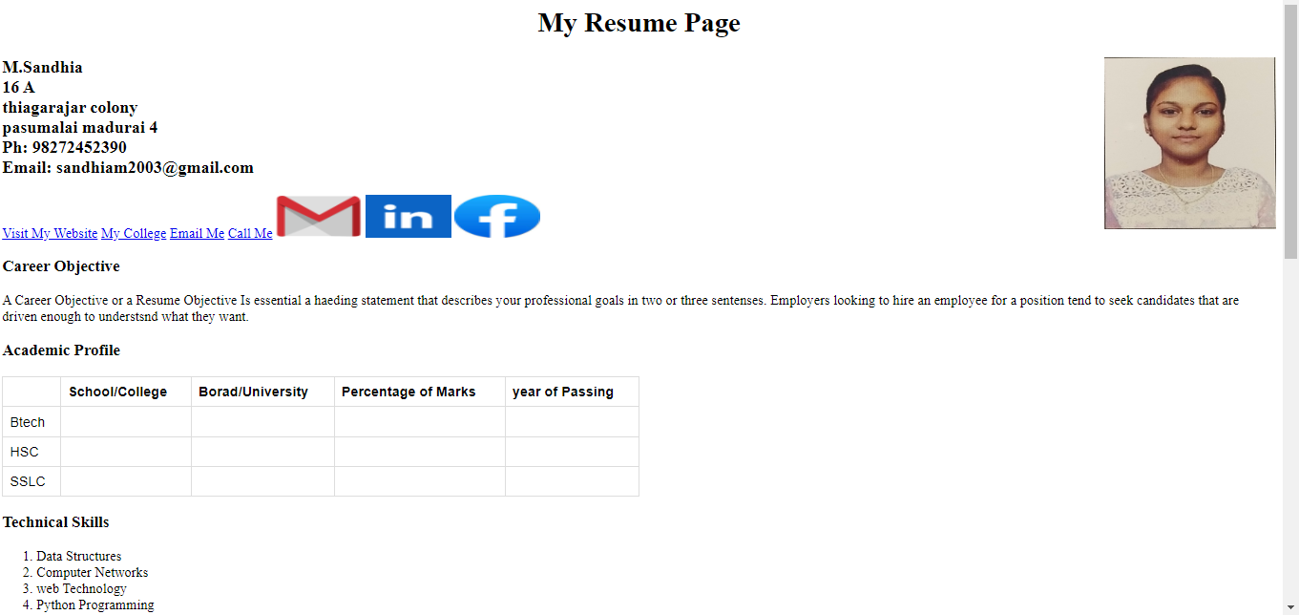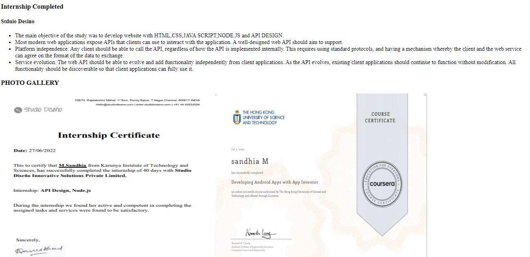

**Result**

Thus a HTML web page for Personal Profile that conforms to HTML features is coded, compiled and executed successfully.